[Skip to content](https://github.com/DynamoDS/Dynamo/issues/4776#start-of-content)

Top of Form

This repository



Bottom of Form

* [**Pull requests**](https://github.com/pulls)
* [**Issues**](https://github.com/issues)
* [**Gist**](https://gist.github.com/)
* **[@jhubers](https://github.com/jhubers)**

Top of Form

[**Watch**](https://github.com/DynamoDS/Dynamo/subscription)[**108**](https://github.com/DynamoDS/Dynamo/watchers)

Bottom of Form

Top of Form

 Star[**244**](https://github.com/DynamoDS/Dynamo/stargazers)

Bottom of Form

Top of Form

 Fork[**183**](https://github.com/DynamoDS/Dynamo/network)

Bottom of Form

[DynamoDS](https://github.com/DynamoDS)/[**Dynamo**](https://github.com/DynamoDS/Dynamo)

Edit[**New issue**](https://github.com/DynamoDS/Dynamo/issues/new)

how to get the input from the input nodes #4776

**Open**

[**jhubers**](https://github.com/jhubers) opened this issue on 23 Jun · 54 comments

Top of Form

**Labels**

None yet

Bottom of Form

Top of Form

**Milestone**

No milestone

Bottom of Form

Top of Form

**Assignee**

No one assigned

Bottom of Form

**Notifications**

Top of Form

 Unsubscribe

Bottom of Form

You’re receiving notifications because you were mentioned.

**4 participants**

[@jhubers](https://github.com/jhubers)[@holyjewsus](https://github.com/holyjewsus)[@ke-yu](https://github.com/ke-yu)[@tatlin](https://github.com/tatlin)

[](https://github.com/jhubers)

[**jhubers**](https://github.com/jhubers)commented [on 23 Jun](https://github.com/DynamoDS/Dynamo/issues/4776#issue-90447626)

Hi,  
I am trying to develop some custom nodes.  
I would like to add semicolons to several inputs and then output it as one string. How do I get the input from the input nodes?

Top of Form

Bottom of Form

[](https://github.com/holyjewsus)

Collaborator

[**holyjewsus**](https://github.com/holyjewsus)commented [on 23 Jun](https://github.com/DynamoDS/Dynamo/issues/4776#issuecomment-114599018)

Hi [**@jhubers**](https://github.com/jhubers) I'm a bit confused - do you mean custom nodes developed through the UI? or do you mean nodes developed in c#?

[](https://github.com/jhubers)

Top of Form

Bottom of Form

[**jhubers**](https://github.com/jhubers)commented [on 23 Jun](https://github.com/DynamoDS/Dynamo/issues/4776#issuecomment-114654201)

Hi, I try developing in C#, folowing the HelloDynamo sample.

Top of Form

Bottom of Form

[](https://github.com/ke-yu)

Owner

[**ke-yu**](https://github.com/ke-yu)commented [29 days ago](https://github.com/DynamoDS/Dynamo/issues/4776#issuecomment-114770890)

[**@jhubers**](https://github.com/jhubers) , you could try String.Join:

[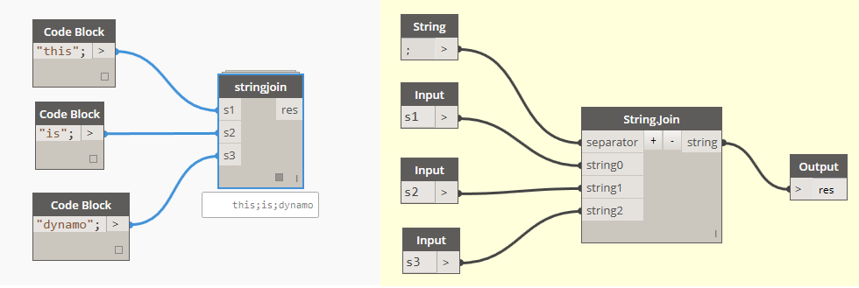](https://cloud.githubusercontent.com/assets/2600379/8325116/72094e60-1a89-11e5-95c6-f5b8374e373c.png)

BTW, seems we can't write ";" in code block node. [**@monikaprabhu**](https://github.com/monikaprabhu) , we need to log a bug for it).

[](https://github.com/jhubers)

Top of Form

Bottom of Form

[**jhubers**](https://github.com/jhubers)commented [29 days ago](https://github.com/DynamoDS/Dynamo/issues/4776#issuecomment-114774610)

[**@ke-yu**](https://github.com/ke-yu), I mean inside a C# custom node. E.g. I have: InPortData.Add(new PortData("P", "Parameter name as string.")); Now inside my custom node I want to add ";" to what ever was connected to this InPort. Do I have to use TryGetValue. If so with what attributes?

Top of Form

Bottom of Form

[](https://github.com/ke-yu)

Owner

[**ke-yu**](https://github.com/ke-yu)commented [29 days ago](https://github.com/DynamoDS/Dynamo/issues/4776#issuecomment-114792470)

Hi [**@jhubers**](https://github.com/jhubers) , sorry, I thought you asked how to do that with Dynamo's custom node.

Do you mean CustomNodeModel in HelloDyanmo sample? As Dynamo internally compiles nodes to DesignScript code, instead of directly getting value from input, we have to use DesignScript AST to implement the custom node model logic. For example, in custom node mode's BuildOutputAst()function:

var semiColon = AstFactor.BuildStringNode(";");

var arguments = new List<AssociativeNode>() {

// suppose custom node model only has one input

inputAstNodes[0],

semiColon};

// To append ";" to input string, use +. For example, "hello" + ";"

// + operation is actually a function call %add(x, y), so we create a function call node

var funcNode = AstFactory.BuildFunctionCall("%add", arguments);

return new[]

{

AstFactory.BuildAssignment(GetAstIdentifierForOutputIndex(0), funcNode);

};

You may take a look at CustomNodeModel.BuildOutputAst()

[](https://github.com/jhubers)

Top of Form

Bottom of Form

[**jhubers**](https://github.com/jhubers)commented [29 days ago](https://github.com/DynamoDS/Dynamo/issues/4776#issuecomment-114808475)

Hi [**@ke-yu**](https://github.com/ke-yu), It is confusing. I try to develop a dll that, when put in the Dynamo nodes folder, makes a menu entry with my nodes. One of the nodes should prepare additional input for a csv file. In the Netherlands we use semicolons as separator. I would expect that the inputs of my node are stored in a list or dictionary or whatever kind of array. Then iterating through that I could add the semicolon to List myList, to be used in AstFactory.BuildAssignment( GetAstIdentifierForOutputIndex(0), AstFactory.BuildExprList(myList)), I was not familiar with TryGetValue and thought it was a method from Dynamo, but now I found that it is a regular C# method and found the description. I will try to use that. Seems more logical to me. But otherwise use your solution. Thanks.

Top of Form

Bottom of Form

[](https://github.com/ke-yu)

Owner

[**ke-yu**](https://github.com/ke-yu)commented [29 days ago](https://github.com/DynamoDS/Dynamo/issues/4776#issuecomment-114849168)

Hi [**@jhubers**](https://github.com/jhubers) , if your implementation is in a C# dll, you don't need to deal withGetAstIdentifierForOutputIndex(0) or whatever AST node, or even don't need to deal with InputPort(Dynamo will automatically create for you when you import it into Dynamo), just write a normal C# function, and import C# dll into Dynamo (Edit | Import Library), then you nodes will be displayed in library view.

[](https://github.com/tatlin)

Collaborator

[**tatlin**](https://github.com/tatlin)commented [29 days ago](https://github.com/DynamoDS/Dynamo/issues/4776#issuecomment-114879253)

This is overkill, you do not need to deal with AST unless you need custom UI of some sort or need access to a lower-level part of dynamo. Take a look at some of the samples and tutorials for loading dlls via dynamo's "zero touch import" capability. <https://github.com/DynamoDS/Dynamo/wiki/Zero-Touch-Plugin-Development> "In most cases, C# static methods and Classes can be imported without modification. If your library only needs to call functions, and not construct new objects, this can be achieved very easily with static methods. When Dynamo loads your DLL, it will strip off the namespace of your classes, and expose all static methods as nodes. " Also if all you are needing is csv export via a different delimiter you should not need to write your own dll at all. Take a look at the csv exporter nodes and the excel interop nodes

[**…**](https://github.com/DynamoDS/Dynamo/issues/4776)

[](https://github.com/jhubers)

Top of Form

Bottom of Form

[**jhubers**](https://github.com/jhubers)commented [29 days ago](https://github.com/DynamoDS/Dynamo/issues/4776#issuecomment-114881896)

Hi Matt,  
It is about several nodes. Preparing a string of seperated inputs to add to a csv file is just one of the functions. One of the nodes has indeed a customized UI.

Top of Form

Bottom of Form

[](https://github.com/holyjewsus)

Collaborator

[**holyjewsus**](https://github.com/holyjewsus)commented [29 days ago](https://github.com/DynamoDS/Dynamo/issues/4776#issuecomment-114897399)

hi [**@jhubers**](https://github.com/jhubers) did [**@ke-yu**](https://github.com/ke-yu) 's example solve the issue / get you started?

[](https://github.com/jhubers)

Top of Form

Bottom of Form

[**jhubers**](https://github.com/jhubers)commented [28 days ago](https://github.com/DynamoDS/Dynamo/issues/4776#issuecomment-115153243)

hi [**@holyjewsus**](https://github.com/holyjewsus) in fact it helped only for one node. An other node needs to add the inported data to a DataTable. Is TryGetValue then the right way to go?

Top of Form

Bottom of Form

[](https://github.com/jhubers)

Top of Form

Bottom of Form

[**jhubers**](https://github.com/jhubers)commented [28 days ago](https://github.com/DynamoDS/Dynamo/issues/4776#issuecomment-115210755)

Found this solution. Is this the way to go?  
for (int i = 0; i < Inputs.Count ; i++)  
{  
var item = Inputs[i];  
Dynamo.Nodes.CodeBlockNodeModel itemValue = (Dynamo.Nodes.CodeBlockNodeModel)item.Item2;  
string s = itemValue.Code;  
//for some reason Dynamo puts "\" and \";" around the string  
string sCleaned = s.Remove(s.Length - 2).Remove(0, 1);  
}

Top of Form

Bottom of Form

[](https://github.com/holyjewsus)

Collaborator

[**holyjewsus**](https://github.com/holyjewsus)commented [28 days ago](https://github.com/DynamoDS/Dynamo/issues/4776#issuecomment-115363359)

Hi [**@jhubers**](https://github.com/jhubers) it looks like you are directly interacting with nodes in the graph, which could potentially be unsafe. It's difficult to reason about the state all other nodes are in.

What are you trying to accomplish with this work? What do you mean by a data table? If you need to access the raw code of the code block then what you're doing is probably okay, but inside your Abstract syntax tree creation you can call arbitrary c# functions you write, so you could take the inputnodes and call your c# which writes them out to whatever data structure you need. This c# code must be defined in another assembly than the node itself is written in.

Another alternative is writing a node with UI where the code is called on the view customizer, similar to the ColorRange node

[](https://github.com/jhubers)

Top of Form

Bottom of Form

[**jhubers**](https://github.com/jhubers)commented [27 days ago](https://github.com/DynamoDS/Dynamo/issues/4776#issuecomment-115615722)

Hi [**@holyjewsus**](https://github.com/holyjewsus)   
First I have to state that I am not a programmer. I picked up some knowledge by doing. I am working on a research project called pCOLAD, as presented and published at the eCAADe 2014 conference. I want to extend it from Grasshopper to Dynamo. That meant from vb.net and Windows Forms to C#, xaml and MVVM (quite a step!).

pCOLAD is about multidisciplinary parametric design. The idea is that different disciplines use some crucial shared parameters and are immediately informed if a value of a shared parameter is changed. Since a CSV file is easy for all disciplines to handle, I need a pCOLLECT node to gather the crucial parameters and values in the Dynamo solution. And link that to a pSHARE node, that displays a copy of the CSV file (a xaml control with a DataGrid bound to a DataTable) and adds the output of pCOLLECT. A pPARAM node uses the output of pSHARE to find the parameters and values that are needed from other team members (see attached image). Of course it is more complex than this. In order to understand what a parameter is about, you have to add several attributes. This must be flexible. So pCOLLECT should have the possibility to add parameter inputs. And some smart mapping of different attributes is needed.

As written above I found a way to turn the input of pCOLLECT into CSV format output. Now I linked that to an input of pSHARE, but again have difficulties to use it (in the image it is faked). I use the Inputs Dictionary to find the data. But need to know the type of course. It turns out to be of type pCOLLECT. I was expecting a Dynamo type like Dynamo.Nodes.CodeBlockNodeModel.

But you say this is an unsafe way. Do you mean that it is not reliable, or that in future versions of Dynamo it will not work (as I noticed going from 0.7 to 0.8). The last is not a big problem. It is a research project. Once Dynamo is more stable I plan to find funding for a test case project.  
[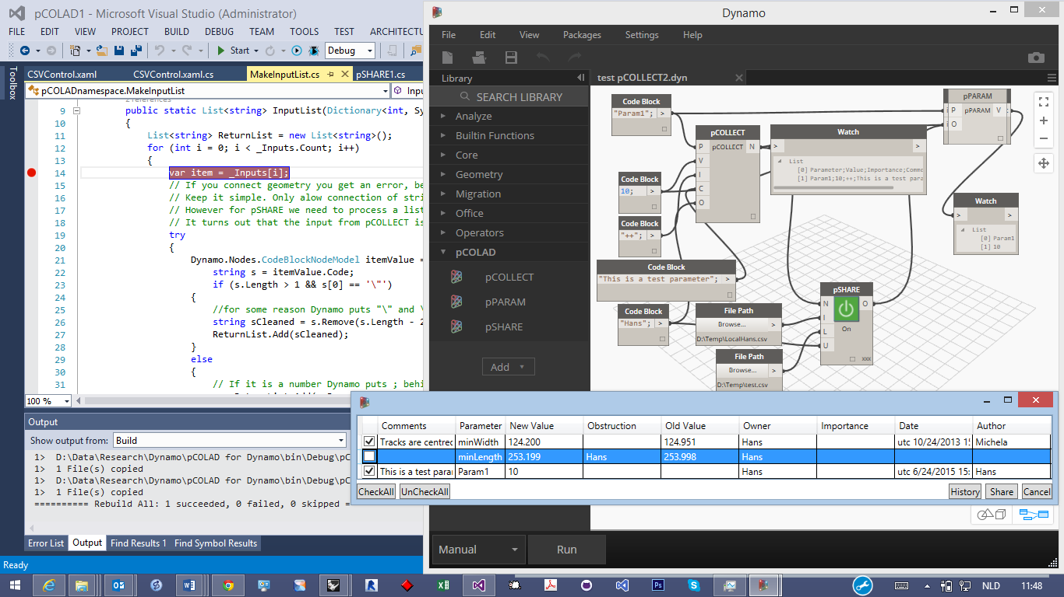](https://cloud.githubusercontent.com/assets/1529297/8374915/5c6f7e32-1bf9-11e5-9494-909f72f42d21.png)

Top of Form

Bottom of Form

[](https://github.com/jhubers)

Top of Form

Bottom of Form

[**jhubers**](https://github.com/jhubers)commented [25 days ago](https://github.com/DynamoDS/Dynamo/issues/4776#issuecomment-116286072)

Now if I connect a File Path node and check the type in Inputs, it turns out to be a DSCore.File.Filename. But if I try to use this as a type I get the error: "The type name 'Filename' does not exist in the type 'DSCore.File'". If I try to use DSCore.IO.FilePath I get the error: "Cannot declare a variable of static type 'DSCore.IO.FilePath'".

How do I get the file path in my custom UI node?

Top of Form

Bottom of Form

[](https://github.com/ke-yu)

Owner

[**ke-yu**](https://github.com/ke-yu)commented [25 days ago](https://github.com/DynamoDS/Dynamo/issues/4776#issuecomment-116374265)

hi [**@jhubers**](https://github.com/jhubers) , DSCore.File.Filename is the type of File Path node, but File Path node should only output string.

I'm afraid you have to write a little bit AST nodes, similar toSampleLibraryUI.Examples.CustomNodeModel.BuildOutputAst(), where

[IsVisibleInDynamoLibrary(false)]

public override IEnumerable<AssociativeNode> BuildOutputAst(List<AssociativeNode> inputAstNodes)

{

....

var funcNode = AstFactory.BuildFunctionCall(

new Func<double,double>(SampleUtilities.MultiplyInputByNumber),

new List<AssociativeNode>(){doubleNode});

....

}

You may implement your logic in a static class, for example:

public static class MyDataCollector

{

[IsVisibleInDynamoLibrary(false)]

public static string pCollect(string filePath, int foo, double bar);

{

...

}

}

And in you custom node model's BuildOutputAst(), change that line to:

[IsVisibleInDynamoLibrary(false)]

public override IEnumerable<AssociativeNode> BuildOutputAst(List<AssociativeNode> inputAstNodes)

{

....

var funcNode = AstFactory.BuildFunctionCall(

// Create my function MyDataCollector.pCollect with some inputs

// Func<string, int, double, string> is my function's signature

new Func<string, int, dobule, string>(MyDataCollector.pCollect),

inputAstNodes);

....

}

And that's it! If you connect File Path to, say the first input port of custom node, you should get a string.

We don't directly deal with specific nodes in a custom node's implementation (for example, won't care about if the input is CodeBlockNodeModel or whatever else). The inputs are either primitive types like integer, string, a List of string or some public types that defined in custom node library and will be imported by Dynamo.

[](https://github.com/jhubers)

Top of Form

Bottom of Form

[**jhubers**](https://github.com/jhubers)commented [24 days ago](https://github.com/DynamoDS/Dynamo/issues/4776#issuecomment-116529872)

Hi [**@ke-yu**](https://github.com/ke-yu) Thanks for your help. Sorry, for asking simple questions. I am a beginner.SampleLibraryUI.Examples.CustomNodeModel.BuildOutputAst(). I opend D:...\Dynamo-RC0.8.0_master\Dynamo-RC0.8.0_master\src\Dynamo.All.2013.sln. Not the right version?  
In there I found something similar to your example:

public override IEnumerable<AssociativeNode> BuildOutputAst(List<AssociativeNode> inputAstNodes)

{

//var functionCall = AstFactory.BuildFunctionCall("Color", "BuildColorFromRange", inputAstNodes);

var functionCall =

AstFactory.BuildFunctionCall(

new Func<Color, Color, double, Color>(Color.BuildColorFromRange),

inputAstNodes);

return new[]

{

AstFactory.BuildAssignment(GetAstIdentifierForOutputIndex(0), functionCall)

};

}

I found the definition of Func:  
public delegate TResult Func<in T1, in T2, in T3, out TResult>(T1 arg1, T2 arg2, T3 arg3);comments say: "Encapsulates a method that has three parameters and returns a value of the type specified by the TResult parameter."  
And so I understand that between () is a method that I should implement as a property of a public static class that returns the three arguments.   
In your example:   
new Func<string, int, dobule, string>(MyDataCollector.pCollect) it will return a string. So I could write  
string myString = new Func<string, int, double, string>(MyDataCollector.pCollect)  
Then var functionCall = (AstFactory.BuildFunctionCall(myString, inputAstNodes)while allinputAstNodes are processed? I guess I have to make a list<AstNodes> of only inputAstNodes[index], where index is the integer of the corresponding input. And replace inputAstNodes with that list? But what parameters (string, int, double ) should be given to MyDataCollector.pCollect? You write:  
public static string pCollect(string filePath, int foo, double bar);  
But the filePath is what I am looking for? And what should go into foo andbar?

Top of Form

Bottom of Form

[](https://github.com/ke-yu)

Owner

[**ke-yu**](https://github.com/ke-yu)commented [24 days ago](https://github.com/DynamoDS/Dynamo/issues/4776#issuecomment-116596424)

hi [**@jhubers**](https://github.com/jhubers) , you could find the file here:https://github.com/DynamoDS/Dynamo/blob/RC0.8.1_master/src/Libraries/Samples/SampleLibraryUI/Examples/CustomNodeModel.cs.

And yes, when you write

var functionCall = AstFactory.BuildFunctionCall(new Func<string, int, dobule, string>(MyDataCollector.pCollect), inputAstNodes)...

you could assume that all inputAstNodes are processed: these inputs finally will be converted to primitive type like int, double, string, etc. and input to your C# static function MyDataCollector.pCollect(), so you C# function doesn't need to worry about all Dynamo related data types, just deal with C# primitive type in most cases.

inputAstNodes in BuildOutputAst() is already a list, no need to change it, unless you don't need some of them of want to change them...

The function pCollect() that I wrote here just is an example, you could change its signature based on your requirement.

Regarding to filePath, when you connect the output from File Path node, the receiver will get a string of the full path of file that you select.

[](https://github.com/jhubers)

Top of Form

Bottom of Form

[**jhubers**](https://github.com/jhubers)commented [24 days ago](https://github.com/DynamoDS/Dynamo/issues/4776#issuecomment-116660607)

[**@ke-yu**](https://github.com/ke-yu) Thanks for the link to the newer version. But still it is not clear to me. In that version I indeed see that a public static class is used. But there it returns a value:

public static class SampleUtilities

{

[IsVisibleInDynamoLibrary(false)]

public static double MultiplyInputByNumber(double input)

{

return input * 42;

}

}

So, I think I have to return a string then. But if I do it like:

var funcNode = AstFactory.BuildFunctionCall(

new Func<string, string>(MyDataCollector.filePath),inputAstNodes);

and my class:

public static class MyDataCollector

{

[IsVisibleInDynamoLibrary(false)]

public static string filePath(string _filePath)

{

return _filePath;

}

}

Nothing happens. In debugging mode it shows that var funcNode becomes  
{pCOLADnamespace.MyDataCollector.filePath(var_870b02ecd0574a5585b1d8a8017e4b58_out0, var_b97e5c2766024e14b2d0be99c8518a19_out0, var_dc8ab1c4298f45a9a162f2e5f8151a49_out0, temp_0_ca98164ada7e407fb237217fd91598b6)} ProtoCore.AST.AssociativeAST.AssociativeNode {ProtoCore.AST.AssociativeAST.IdentifierListNode}. But stepping through the code doesn't go to the MyDataCollector class. How do I get the path in a string variable so I can use it to open a file?

Do I have to install version 0.8.1?

Top of Form

Bottom of Form

[](https://github.com/holyjewsus)

Collaborator

[**holyjewsus**](https://github.com/holyjewsus)commented [24 days ago](https://github.com/DynamoDS/Dynamo/issues/4776#issuecomment-116667250)

hi [**@jhubers**](https://github.com/jhubers) please try defining your DataCollector class in another assembly, this means another project than the UI node itself is defined in. I think this may help.

[](https://github.com/jhubers)

Top of Form

Bottom of Form

[**jhubers**](https://github.com/jhubers)commented [24 days ago](https://github.com/DynamoDS/Dynamo/issues/4776#issuecomment-116709224)

Hi [**@holyjewsus**](https://github.com/holyjewsus) in another project? That means another dll? Have to reference it then in the first project. Tried it. There is no difference. For testing I used:  
var t = new Func<string, string>(MyDataCollector.MyDataCollector.filePath);  
When debugging t shows:   
[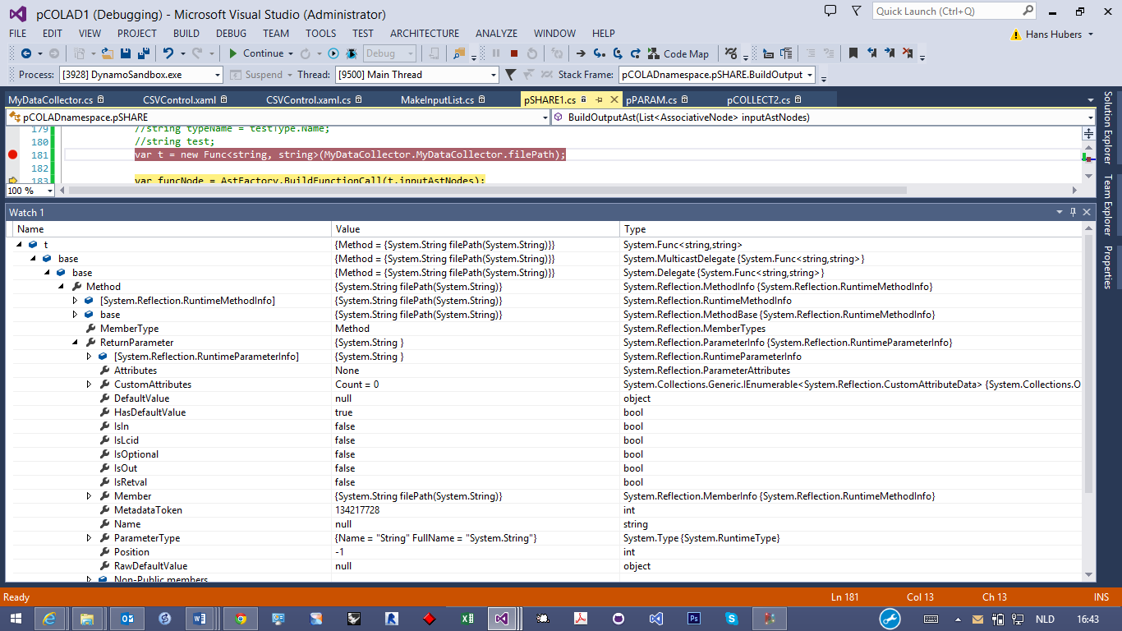](https://cloud.githubusercontent.com/assets/1529297/8410298/a380e32a-1e7d-11e5-87ad-d7eca83ae275.png)

Top of Form

Bottom of Form

[](https://github.com/ke-yu)

Owner

[**ke-yu**](https://github.com/ke-yu)commented [24 days ago](https://github.com/DynamoDS/Dynamo/issues/4776#issuecomment-116710008)

hi [**@jhubers**](https://github.com/jhubers), stepping through the code won't go to MyDataCollector class. Here it is compiling inputs and your custom node logic to internal DesignScript representation, and later on the execution engine will hook up the static function in MyDataCollector class and run it.

Setting a break point in your static function to verify whether it will be executed in the future or not.

[](https://github.com/jhubers)

Top of Form

Bottom of Form

[**jhubers**](https://github.com/jhubers)commented [24 days ago](https://github.com/DynamoDS/Dynamo/issues/4776#issuecomment-116721857)

hi [**@ke-yu**](https://github.com/ke-yu) I have set a break point in MyDataGollector class. But it isn't hit. Also the node gives an error:  
[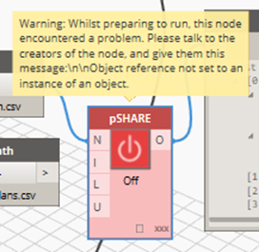](https://cloud.githubusercontent.com/assets/1529297/8410874/2fdb65e0-1e81-11e5-9515-32c412e1f8d4.png)

Top of Form

Bottom of Form

[](https://github.com/jhubers)

Top of Form

Bottom of Form

[**jhubers**](https://github.com/jhubers)commented [24 days ago](https://github.com/DynamoDS/Dynamo/issues/4776#issuecomment-116725448)

That error was due to not all inputs being connected. But still not clear to me, how I can get a string variable with the file path...

Top of Form

Bottom of Form

[](https://github.com/holyjewsus)

Collaborator

[**holyjewsus**](https://github.com/holyjewsus)commented [24 days ago](https://github.com/DynamoDS/Dynamo/issues/4776#issuecomment-116757949)

Hi [**@jhubers**](https://github.com/jhubers)

[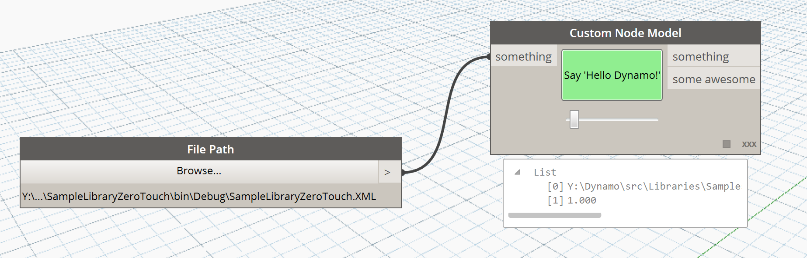](https://cloud.githubusercontent.com/assets/508936/8412358/5e48c6ea-1e57-11e5-8fc1-0f69b440cf4d.png)

please see this modified example of the hello world custom node model sample to see how I got a string.

[IsVisibleInDynamoLibrary(false)]

public override IEnumerable<AssociativeNode> BuildOutputAst(List<AssociativeNode> inputAstNodes)

{

var funcNode = AstFactory.BuildFunctionCall(

new Func<string,string>(SampleUtilities.StringReturnString),

inputAstNodes);

return new[]

{

AstFactory.BuildAssignment(

GetAstIdentifierForOutputIndex(0), funcNode),

AstFactory.BuildAssignment(

GetAstIdentifierForOutputIndex(1),

AstFactory.BuildDoubleNode(awesome))

};

}

in sampleUtilities.cs I defined a new public static method I call from inside the buildAST method

[IsVisibleInDynamoLibrary(false)]

public static string StringReturnString(string instring)

{

return instring;

}

[](https://github.com/holyjewsus)

Collaborator

[**holyjewsus**](https://github.com/holyjewsus)commented [24 days ago](https://github.com/DynamoDS/Dynamo/issues/4776#issuecomment-116758647)

It may help to see that in this build output AST method we're not actually doing any evaluation of the node, we're just creating a syntax tree of expressions that will be evaluated in the future when the node is called with some inputs.

[](https://github.com/jhubers)

Top of Form

Bottom of Form

[**jhubers**](https://github.com/jhubers)commented [23 days ago](https://github.com/DynamoDS/Dynamo/issues/4776#issuecomment-117042204)

Hi [**@holyjewsus**](https://github.com/holyjewsus) Thanks for the example, but It doesn't show how and where you can get the file path in your code so you can open a file and process it in your code. It somewhere hidden in this Func. How can I get it out?

Top of Form

Bottom of Form

[](https://github.com/holyjewsus)

Collaborator

[**holyjewsus**](https://github.com/holyjewsus)commented [23 days ago](https://github.com/DynamoDS/Dynamo/issues/4776#issuecomment-117173086)

[**@jhubers**](https://github.com/jhubers) you can do your processing inside that func - "stringreturnstring" You can call other c# inside that func as well, this could have side effects, like taking the string and writing it to csv. I think, [**@ke-yu**](https://github.com/ke-yu) to make sure that is safe.

[](https://github.com/jhubers)

Top of Form

Bottom of Form

[**jhubers**](https://github.com/jhubers)commented [22 days ago](https://github.com/DynamoDS/Dynamo/issues/4776#issuecomment-117651137)

Hi [**@holyjewsus**](https://github.com/holyjewsus), I think I understand what you mean. However, since it is a static class that we use, how can we access what happens inside? We can not make an instance to access a property. I found another error in my code. I forgot to change the output from   
return new[] { AstFactory.BuildAssignment(GetAstIdentifierForOutputIndex(0), AstFactory.BuildExprList(inputAstNodes)), }; to  
return new[] { AstFactory.BuildAssignment(GetAstIdentifierForOutputIndex(0), funcNode), };  
But now I get next error:  
[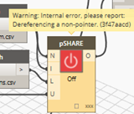](https://cloud.githubusercontent.com/assets/1529297/8454891/e4b98d04-2000-11e5-8d5a-cf50fcca3b30.png)  
Any idea what that means?

Top of Form

Bottom of Form

[](https://github.com/ke-yu)

Owner

[**ke-yu**](https://github.com/ke-yu)commented [22 days ago](https://github.com/DynamoDS/Dynamo/issues/4776#issuecomment-117888568)

Hi [**@jhubers**](https://github.com/jhubers), that means some inputs are incorrect. Could you show the signature of C# static function that pSHARE that invokes? What's type of input 'N'? And are 'I', 'L', 'U' strings? Could you connect these inputs to WATCH node to see what they are?

[](https://github.com/jhubers)

Top of Form

Bottom of Form

[**jhubers**](https://github.com/jhubers)commented [21 days ago](https://github.com/DynamoDS/Dynamo/issues/4776#issuecomment-117953717)

Hi [**@ke-yu**](https://github.com/ke-yu), I cleaned out all extra properties and methods of pSHARE.cs. But still the error as shown in picture below. I don't see that somewhere the type of the inputs is defined. Am I missing something? N is output of List.Create node. I and L are outputs of File Path node and U is output of a Code Block node.

The cleaned code of pSHARE.cs:

using System.Collections.Generic;

using Autodesk.DesignScript.Runtime;

using Dynamo.Controls;

using Dynamo.Models;

using ProtoCore.AST.AssociativeAST;

using System;

using Dynamo.Wpf;

namespace pCOLADnamespace

{

#region some node settings

/// pSHARE takes care of the communication of parameter changes through a shared *.csv file.

[NodeName("pSHARE")]

[NodeCategory("pCOLAD")]

[NodeDescription("Load and share changes to parameters.")]

[IsDesignScriptCompatible]

#endregion

public class pSHARE : NodeModel

{

#region constructor

/// The constructor for a NodeModel is used to create the input and output ports and specify the argument lacing.

public pSHARE()

{

InPortData.Add(new PortData("N", "Input (a List.CreateList) of pCOLLECT output(s)"));

InPortData.Add(new PortData("I", "Input a FilePath for the shared csv files."));

InPortData.Add(new PortData("L", "Input a FilePath for the local copy of the csv file."));

InPortData.Add(new PortData("U", "Input a the user namen (Code Block)."));

OutPortData.Add(new PortData("O", "Output of parameter name and value on next line; two by two."));

RegisterAllPorts();

ArgumentLacing = LacingStrategy.CrossProduct;

}

#endregion

#region public methods

/// <summary>

/// If this method is not overriden, Dynamo will, by default

/// pass data through this node. So we should later use it to pass the OutputList.

/// </summary>

/// <param name="inputAstNodes"></param>

/// <returns></return

[IsVisibleInDynamoLibrary(false)]

public override IEnumerable<AssociativeNode> BuildOutputAst(List<AssociativeNode> inputAstNodes)

{

var t = new Func<string, string>(MyDataCollector.MyDataCollector.filePath);

var funcNode = AstFactory.BuildFunctionCall(t,inputAstNodes);

return new[] { AstFactory.BuildAssignment(GetAstIdentifierForOutputIndex(0), funcNode)};

}

public class pSHARENodeViewCustomization : INodeViewCustomization<pSHARE>

{

/// <summary>

/// At run-time, this method is called during the node

/// creation. Here you can create custom UI elements and

/// add them to the node view, but we recommend designing

/// your UI declaratively using xaml, and binding it to

/// properties on this node as the DataContext.

/// </summary>

/// <param name="model">The NodeModel representing the node's core logic.</param>

/// <param name="nodeView">The NodeView representing the node in the graph.</param>

public void CustomizeView(pSHARE model, NodeView nodeView)

{

var pSHAREControl = new pSHAREcontrol();

nodeView.inputGrid.Children.Add(pSHAREControl);

pSHAREControl.DataContext = model;

}

/// <summary>

/// Here you can do any cleanup you require if you've assigned callbacks for particular

/// UI events on your node.

/// </summary>

public void Dispose() { }

}

#endregion

}

}

The code of a separate project MyDataCollector:

using Autodesk.DesignScript.Runtime;

namespace MyDataCollector

{

public static class MyDataCollector

{

[IsVisibleInDynamoLibrary(false)]

public static string filePath(string _filePath)

{

return _filePath;

}

}

}

[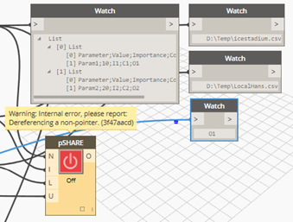](https://cloud.githubusercontent.com/assets/1529297/8472507/28bcddca-20a2-11e5-837a-e1e273dd8ecf.png)

Top of Form

Bottom of Form

[](https://github.com/jhubers)

Top of Form

Bottom of Form

[**jhubers**](https://github.com/jhubers)commented [21 days ago](https://github.com/DynamoDS/Dynamo/issues/4776#issuecomment-117991635)

Might it be that the error comes from the fact that MyDataCollectorClass is an extension method. For this to work we must put a using MyDataCollector (the name space). And a method should have () behind it? However this gives next error:  
[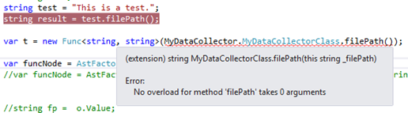](https://cloud.githubusercontent.com/assets/1529297/8474772/e5bf13f6-20b2-11e5-8612-fdd6003698db.png)

Intellisense shows:  
[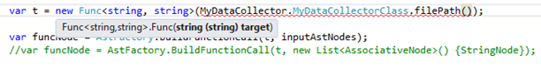](https://cloud.githubusercontent.com/assets/1529297/8474853/9ffc7ee8-20b3-11e5-88a5-8089cb48c745.png)

I don't understand what should go between () in .filePath().

Top of Form

Bottom of Form

[](https://github.com/ke-yu)

Owner

[**ke-yu**](https://github.com/ke-yu)commented [21 days ago](https://github.com/DynamoDS/Dynamo/issues/4776#issuecomment-118066601)

hi [**@jhubers**](https://github.com/jhubers) , your custom node pSHARE has *4* inputs, but the C# function it tries to call,MyDataCollectorClass.filePath(string) only has *one parameter*, which is expected to be a string, therefore at runtime Dynamo is not able to call this static function.

And when you are creating a Func<>, () is not needed, otherwise it will become a function call instead of creating a Func<> object which points to that static function.

[](https://github.com/jhubers)

Top of Form

Bottom of Form

[**jhubers**](https://github.com/jhubers)commented [21 days ago](https://github.com/DynamoDS/Dynamo/issues/4776#issuecomment-118084075)

hi [**@ke-yu**](https://github.com/ke-yu) , thanks, this makes sense. But I tried now with next solution:

var t = new Func<List<string>,string,string, string, List<object>>(MyDataCollector.MyDataCollectorClass.pSHAREinputs);

And the function:

using Autodesk.DesignScript.Runtime;

using System;

using System.Collections.Generic;

using System.Linq;

using System.Text;

using System.Threading.Tasks;

using System.Windows;

namespace MyDataCollector

{

public static class MyDataCollectorClass

{

[IsVisibleInDynamoLibrary(false)]

public static List<object> pSHAREinputs( List<string> _Ninputs, string _IfilePath, string _LfilePath, string _owner)

{

System.Windows.MessageBox.Show("The file path = " + _IfilePath);

List<object> _pSHAREinputs = new List<object> { _Ninputs, _IfilePath, _LfilePath, _owner };

return _pSHAREinputs;

}

}

}

But same error of Dereferencing a non-pointer. (3f47aacd)... What else is wrong?

Top of Form

Bottom of Form

[](https://github.com/ke-yu)

Owner

[**ke-yu**](https://github.com/ke-yu)commented [21 days ago](https://github.com/DynamoDS/Dynamo/issues/4776#issuecomment-118203680)

[**@jhubers**](https://github.com/jhubers) , firstly, could you remove   
[IsVisibleInDynamoLibrary(false)] before pSHAREInputs, and import the dll into Dynamo to see if Dynamo is able to create a node pSHAREInputs and verify if it works as expected?

If yes, I don't have any clue now, could you share your code somewhere, for example on github, so that I can take a look?

[](https://github.com/jhubers)

Top of Form

Bottom of Form

[**jhubers**](https://github.com/jhubers)commented [20 days ago](https://github.com/DynamoDS/Dynamo/issues/4776#issuecomment-118305926)

[**@ke-yu**](https://github.com/ke-yu) Thanks again for the help. See result in first image. I had to load the dll manually though to see it in the Dynamo menu. So just putting it in the nodes folder of Dynamo didn't work. In the meanwhile I installed version 0.8.1 and had to change Inputs into InputNodes at some places. But I don't think that interfered with getting the inputs for pSHARE. I noticed that I expect to get a List<string> from pCOLLECT, while it shows in the image that it isstring[]. Will change that. Otherwise when I run the solution I get an other error message now (see second image): Warning: Converting an array to var would cause array rank reduction and is not permitted.  
[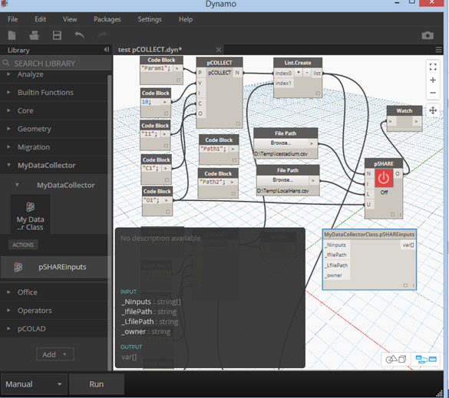](https://cloud.githubusercontent.com/assets/1529297/8497244/eed90d24-217b-11e5-915c-68a6088a96f9.png)  
[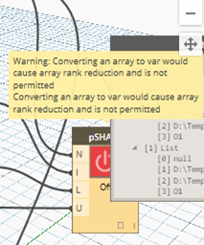](https://cloud.githubusercontent.com/assets/1529297/8497250/f6a520e2-217b-11e5-884f-e790801de343.png)

I would like to put my code on GitHub, but I don't know how. Will try to find out. Next week I don't have time to work on this. But next two weeks I will. Now first try with string[]. Will give the result in some minutes.

Top of Form

Bottom of Form

[](https://github.com/ke-yu)

Owner

[**ke-yu**](https://github.com/ke-yu)commented [20 days ago](https://github.com/DynamoDS/Dynamo/issues/4776#issuecomment-118307820)

[**@jhubers**](https://github.com/jhubers) , List<String> is the type in C#, but string[] is the type in DesignScript. That said, as the data will flow from C# to Dynamo or Dynamo to C#, internally Dynamo will do data marshalling, so no need to worry about List<String> and string[].

[](https://github.com/jhubers)

Top of Form

Bottom of Form

[**jhubers**](https://github.com/jhubers)commented [20 days ago](https://github.com/DynamoDS/Dynamo/issues/4776#issuecomment-118309715)

[**@ke-yu**](https://github.com/ke-yu) Indeed that didn't change. So remain two problems. MyDataCollector.dll doesn't load automatically. If I load it manually, then a warning shows: Converting an array to var would cause array rank reduction and is not permitted. Does that mean that I should change var t = new Func... into an array. But of what type?   
Anyway I have a correct output now and also it breaks inside MyDataCollector.cs and shows that I can use the inputs. Thanks again for your help. Will now try to get everything on GitHub.

Top of Form

Bottom of Form

[](https://github.com/jhubers)

Top of Form

Bottom of Form

[**jhubers**](https://github.com/jhubers)commented [20 days ago](https://github.com/DynamoDS/Dynamo/issues/4776#issuecomment-118360004)

[**@ke-yu**](https://github.com/ke-yu) I think the repository is ready: <https://github.com/jhubers/pCOLAD-for-Dynamo>. Please tell me if it usable like this...

Top of Form

Bottom of Form

[](https://github.com/jhubers)

Top of Form

Bottom of Form

[**jhubers**](https://github.com/jhubers)commented [15 days ago](https://github.com/DynamoDS/Dynamo/issues/4776#issuecomment-119539806)

It turns out that the warning about Converting an array to var comes from the List input. If I change it to string there is no problem. In fact it is not the List input, but the fact that it is added to the List as such. If I convert the List to a string with returns and then add it to the List, there is no problem. Anyway the output should be a List and that works alright.

Top of Form

Bottom of Form

[](https://github.com/jhubers)

Top of Form

Bottom of Form

[**jhubers**](https://github.com/jhubers)commented [15 days ago](https://github.com/DynamoDS/Dynamo/issues/4776#issuecomment-119542520)

Remains the problem of the MyDataCollector.dll not loading automatically. What is needed for a dll to load automatically when it is in the nodes directory of Dynamo?

Top of Form

Bottom of Form

[](https://github.com/ke-yu)

Owner

[**ke-yu**](https://github.com/ke-yu)commented [14 days ago](https://github.com/DynamoDS/Dynamo/issues/4776#issuecomment-119823421)

[**@jhubers**](https://github.com/jhubers), try to put libraries in nodes folder (not verified yet).

[](https://github.com/jhubers)

Top of Form

Bottom of Form

[**jhubers**](https://github.com/jhubers)commented [14 days ago](https://github.com/DynamoDS/Dynamo/issues/4776#issuecomment-119853896)

[**@ke-yu**](https://github.com/ke-yu) Of course. MyDataCollector.dll is in the nodes folder. Just like the pCOLAD.dll. I copy them there with a post-build event. Verified that they are of same recent date. Is it because it is a public static class MyDataCollectorClass and a public static List<string> pSHAREinputs(List<string> _Ninputs, string _IfilePath, string _LfilePath, string _owner)?

Top of Form

Bottom of Form

[](https://github.com/ke-yu)

Owner

[**ke-yu**](https://github.com/ke-yu)commented [14 days ago](https://github.com/DynamoDS/Dynamo/issues/4776#issuecomment-119875475)

hmm, how about creating a [package](https://github.com/DynamoDS/Dynamo/wiki/Building-a-Package-for-Dynamo-in-Visual-Studio)?

[](https://github.com/jhubers)

Top of Form

Bottom of Form

[**jhubers**](https://github.com/jhubers)commented [10 days ago](https://github.com/DynamoDS/Dynamo/issues/4776#issuecomment-120858634)

I tried to reorganize my GitHub repository several times, but found that folder structures in VS are not relevant to GitHub. Reorganizing the folder structure in Explorer caused all kinds of errors in VS. Had to revert, but created the package in a different place. But when the package is in the roaming folder of Dynamo 0.8 next to a downloaded package, only the last one loads. Is the pkg.json file necessary? How do you make that?

Top of Form

Bottom of Form

[](https://github.com/ke-yu)

Owner

[**ke-yu**](https://github.com/ke-yu)commented [10 days ago](https://github.com/DynamoDS/Dynamo/issues/4776#issuecomment-120871787)

[**@pboyer**](https://github.com/pboyer) , [**@riteshchandawar**](https://github.com/riteshchandawar) , any tool to create pkg.json?

[](https://github.com/jhubers)

Top of Form

Bottom of Form

[**jhubers**](https://github.com/jhubers)commented [10 days ago](https://github.com/DynamoDS/Dynamo/issues/4776#issuecomment-120899406)

[**@ke-yu**](https://github.com/ke-yu) I made pkg.json file on the basis of the Zip List package. It works alright now. Thanks for your help.

Top of Form

Bottom of Form

[](https://github.com/jhubers)

Top of Form

Bottom of Form

[**jhubers**](https://github.com/jhubers)commented [9 days ago](https://github.com/DynamoDS/Dynamo/issues/4776#issuecomment-121166967)

Now I can access the inputs in this public static class MyDataCollector. But I need that information in the pSHARE node in order to add it to the csv file and its display in xaml DataGrid. However the public static class MyDataCollector is only called just before creation of the node. If I try to get it after return new[] { AstFactory.BuildAssignment(GetAstIdentifierForOutputIndex(0), funcNode)}; a warning shows that this code is not reachable. I can not reference pSHARE in MyDataCollector, because then a circular reference occurs. So, how can I use the inputs?

Top of Form

Bottom of Form

[](https://github.com/ke-yu)

Owner

[**ke-yu**](https://github.com/ke-yu)commented [4 days ago](https://github.com/DynamoDS/Dynamo/issues/4776#issuecomment-122734672)

hi [**@jhubers**](https://github.com/jhubers) , you can't reference pSHARE. What kind of information that can't be passed toMyDataCollector?

It is a little bit tricky, but you can always create some AST nodes for some values, if they are not from input, and pass them as parameters to you static function defined in MyDataCollector.

For example, in your BuiltOutAst():

public override IEnumerable<AssociativeNode> BuildOutputAst(List<AssociativeNode> inputAstNodes)

{

var t = new Func<string, string>(MyDataCollector.MyDataCollector.filePath);

// instead of using inputASTNodes,

// you can create new input. e.g.,

inputAstNodes[1] = AstFactory.BuildString("foo");

var funcNode = AstFactory.BuildFunctionCall(t,inputAstNodes);

return new[] { AstFactory.BuildAssignment(GetAstIdentifierForOutputIndex(0), funcNode)};

}

[](https://github.com/jhubers)

Top of Form

Bottom of Form

[**jhubers**](https://github.com/jhubers)commented [3 days ago](https://github.com/DynamoDS/Dynamo/issues/4776#issuecomment-122909297)

[**@ke-yu**](https://github.com/ke-yu) the problem was that in the static class I can not use RaisePropertyChanged, which I needed to react on when clicking on a checkbox and probably need it also to show if something changes in the input nodes. Therefore moving all the code to static class MyDataCollector didn't work. Now I have it mixed. Everything that interacts with the display is in the pSHARE node and the rest in static classes. Seems to work, but not yet updating changes in the inputs, without closing and opening the display xaml control. But I am a step further. Thanks.

Top of Form

Bottom of Form

[](https://github.com/jhubers)

Top of Form

Bottom of Form

[**jhubers**](https://github.com/jhubers)commented [21 hours ago](https://github.com/DynamoDS/Dynamo/issues/4776#issuecomment-123816115)

Hi [**@ke-yu**](https://github.com/ke-yu) I can't get the updating of the CSVControl to work when I change a pCOLLECT input and hit the RUN button of Dynamo. Seems a problem is that using a static class you cannot implement theINotifyPropertyChanged interface, because that needs an instance. The problem is that we then can notRaisePropertyChanged("MyPropDataTable") to notify the CSVcontrol that it should update changes formmyDataTable. E.g. after changing inputs of pSHARE or changes in the csv file. The way to go would be to use a singleton? But I don't know if that would work with the   
Func<List<List<string>>, string, string, string, List<string>>(MyDataCollectorClass.pSHAREinputs).  
What do you think?

The repository is now at <https://github.com/jhubers/pCOLAD-for-Dynamo/tree/0.1>

Top of Form

Bottom of Form

[](https://github.com/ke-yu)

Owner

[**ke-yu**](https://github.com/ke-yu)commented [13 hours ago](https://github.com/DynamoDS/Dynamo/issues/4776#issuecomment-123933318)

hi [**@jhubers**](https://github.com/jhubers), I'll take a look when i have time.

[](https://github.com/ke-yu)

Owner

[**ke-yu**](https://github.com/ke-yu)commented [9 hours ago](https://github.com/DynamoDS/Dynamo/issues/4776#issuecomment-123991544)

hi [**@jhubers**](https://github.com/jhubers) , how about event handler? Can we add a event handler to MyDataCollector and add CSVControl as a subscriber and once MyDataCollector finishes execution, it notifies CSVControl to update?

[](https://github.com/jhubers)

Top of Form

Bottom of Form

[**jhubers**](https://github.com/jhubers)commented [3 minutes ago](https://github.com/DynamoDS/Dynamo/issues/4776#issuecomment-124138707)

[**@ke-yu**](https://github.com/ke-yu) Indeed. An event in the static class MyDataCollectorClass does the trick. Still many things to improve, but the coming 4 weeks I am on holiday. Thank you very much for your help. Without it I would have given up.

Top of Form

Bottom of Form

[](https://github.com/jhubers)

Top of Form

[Markdown supported](https://guides.github.com/features/mastering-markdown/) [Edit in fullscreen](https://github.com/DynamoDS/Dynamo/issues/4776#fullscreen)

[Write](https://github.com/DynamoDS/Dynamo/issues/4776) [Preview](https://github.com/DynamoDS/Dynamo/issues/4776)



Attach images by dragging & dropping, [selecting them](https://github.com/DynamoDS/Dynamo/issues/4776), or pasting from the clipboard.

CommentClose issue

Bottom of Form

* [Status](https://status.github.com/)

* [API](https://developer.github.com/)

* [Training](https://training.github.com/)

* [Shop](https://shop.github.com/)

* [Blog](https://github.com/blog)

* [About](https://github.com/about)

* [Help](https://help.github.com/)
* © 2015 GitHub, Inc.

* [Terms](https://github.com/site/terms)

* [Privacy](https://github.com/site/privacy)

* [Security](https://github.com/security)

* [Contact](https://github.com/contact)